Autonomous underwater vehicle for sea water intake
tunnel inspection and cleaning for nuclear plant

Report submitted to GITAM (Deemed to be University) as a partial fulfillment of the requirements for the award of the Degree of Bachelor of Technology in (write your respective branch)
DEPARTMENT OF ELECTRICAL, ELECTRONICS AND COMMUNICATION ENGINEERING
GITAM SCHOOL OF TECHNOLOGY
GITAM (DEEMED TO BE UNIVERSITY)
BENGALURU -561203
NOV 2025

Name:1)Polisetty Karthik (BU22EECE0100334)
2)N Uday Mahesh Teja (BU22EECE0100456)

DECLARATION

I/We declare that the project work contained in this report is original and it has been done by me under the guidance of my project guide.

Name:

1) Polisetty Karthik
2) N Uday Mahesh Teja

Date: Signature of the Student

Department of Electrical, Electronics and Communication Engineering GITAM School of Technology, Bengaluru-561203



CERTIFICATE

This is to certify that (Student Name) bearing (Regd. No.:) has satisfactorily completed Mini Project Entitled in partial fulfillment of the requirements as prescribed by University for VIIth semester, Bachelor of Technology in “Electrical, Electronics and Communication Engineering” and submitted this report during the academic year 2025-2026.

[Signature of the Guide] [Signature of HOD]

Table of contents

Chapter 1: Introduction 1
  - Overview of the problem statement 1
  - Objectives and goals 1
Chapter 2 : Literature Review 2
Chapter 3 : Strategic Analysis and Problem Definition 3
  - SWOT Analysis 3
  - Project Plan - GANTT Chart 3
  - Refinement of problem statement 3
Chapter 4 : Methodology 4
  - Description of the approach 4
  - Tools and techniques utilized 4
  - Design considerations 4
Chapter 5 : Implementation5
  - Description of how the project was executed 5
  - Challenges faced and solutions implemented 5
Chapter 6: Results 6
  - outcome 6
  - Interpretation of results 6
  - Comparison with existing technologies 6
Chapter 7: Conclusion 7
Chapter 8 : Future Work 8
References 9

Chapter 1: Introduction

  - Overview of the problem statement

Nuclear power plants rely on seawater intake systems to cool their reactors and other equipment. These systems are critical to the safe and efficient operation of the plant. However, the seawater intake tunnels can become clogged with debris, sedimentation, and other obstructions, which can reduce the efficiency of the cooling system and potentially lead to safety issues. Traditional inspection and cleaning methods can be time-consuming, expensive, and pose risks to human divers. To address these challenges, this project proposes the design and development of an Autonomous Underwater Vehicle (AUV) using Arduino for inspecting and cleaning seawater intake tunnels in nuclear plants. The AUV will be equipped with advanced sensors, navigation systems, and cleaning mechanisms, enabling it to navigate through the tunnels, detect debris and sedimentation, and perform cleaning operations. The use of Arduino technology will enable the AUV to operate autonomously, reducing the need for human intervention and minimizing the risks associated with traditional inspection and cleaning methods. The AUV will be designed to operate in a variety of water conditions, including varying temperatures, depths, and currents. By developing an AUV specifically designed for seawater intake tunnel inspection and cleaning, this project aims to improve the safety, efficiency, and reliability of nuclear plant operations. The AUV will help to ensure the optimal flow of cooling water, reduce maintenance costs, and minimize the risk of accidents or injuries.

  - Objectives

• Inspect seawater intake tunnels: Use sensors and cameras to detect debris,
sedimentation, or other issues that may affect the tunnel's functionality.
• Clean seawater intake tunnels: Utilize cleaning mechanisms or tools to remove
debris and sedimentation, ensuring optimal water flow.
• Navigate through tunnels: Develop navigation algorithms and control
systems to enable the AUV to maneuver through the tunnels efficiently.
• Collect data: Gather data on water quality, flow rates, and tunnel conditions using
various sensors, such as temperature, pH, and pressure sensors.
• Autonomous operation: Autonomous control and navigation, minimizing
human intervention.

Goals

• Robust Communication: Establish reliable communication systems to
transmit data and control commands between the AUV and the surface.
• Reduced Downtime: Minimize downtime and maintenance costs by
automating inspection and cleaning tasks.
• Reliable Inspection: Conduct thorough inspections of seawater intake tunnels
to detect potential issues, such as debris, sedimentation, or damage.

Chapter 2: Literature Review

1) A Comprehensive Study on Modelling and Control of Autonomous Underwater Vehicle
Author: Rajini Makam, Pruthviraj Mane, Suresh Sundaram, P.B. Sujit
Journal: Not specified
Key Takeaways: This study provides a comprehensive overview of AUV modeling and control strategies, highlighting the importance of accurate hydrodynamic modeling and robust control systems for AUVs operating in challenging underwater environments.

2) A review on the hydrodynamic characteristics of autonomous underwater vehicles
Author: Jyoti Prakash Panda, Arindam Mitra, Hari V Warrior
Journal: Journal of Ocean Engineering
Key Takeaways: This review paper discusses various experimental and numerical methods for analyzing hydrodynamic characteristics of AUVs, emphasizing the importance of understanding these characteristics for better design, control, and navigation.

3) Autonomous Underwater Vehicles and Field of View in Underwater Operations
Author: Isaac Segovia Ramírez, Pedro José Bernalte Sánchez, Mayorkinos Papaelias, Fausto Pedro García Márquez
Journal: Journal of Marine Science and Engineering
Key Takeaways: This paper explores the importance of field of view in underwater operations and discusses how AUVs can be used to optimize inspection and monitoring tasks.

4) Autonomous Underwater Vehicles: Identifying Critical Issues and Future Perspectives in Image Acquisition
Author: Alberto Monterroso Muñoz, Maria-Jose Moron-Fernández, Daniel Cascado-Caballero, Fernando Diaz-del-Rio, Pedro Real
Journal: Sensors
Key Takeaways: This study identifies critical issues in AUV image acquisition, including optical issues, underwater image enhancement, and algorithmic processing, and proposes a global underwater workflow for future applications.

5) Advancements in the field of autonomous underwater vehicle
Author: A. Sahoo, S. K. Dwivedy, P. S. Robi
Journal: IEEE Journal of Ocean Engineering
Key Takeaways: This paper reviews recent advancements in AUV technology, including design, control, and navigation systems, highlighting their applications in various fields.

6) On the Study of Autonomous Underwater Vehicles by Computational Fluid Dynamics
Author: João Victor Nunes de Sousa, Antonio Gilson Barbosa de Lima, Francisco Alves Batista, Edna Cordeiro de Souza, Daniel César de Macedo Cavalcante, Paulo de Morais Pessôa, João Evangelista Franco do Carmo
Journal: Open Journal of Fluid Dynamics
Key Takeaways: This study demonstrates the use of computational fluid dynamics (CFD) in analyzing the hydrodynamic performance of AUVs, providing insights into their design and optimization

Chapter 3 : Strategic Analysis and Problem Definition

  - SWOT Analysis
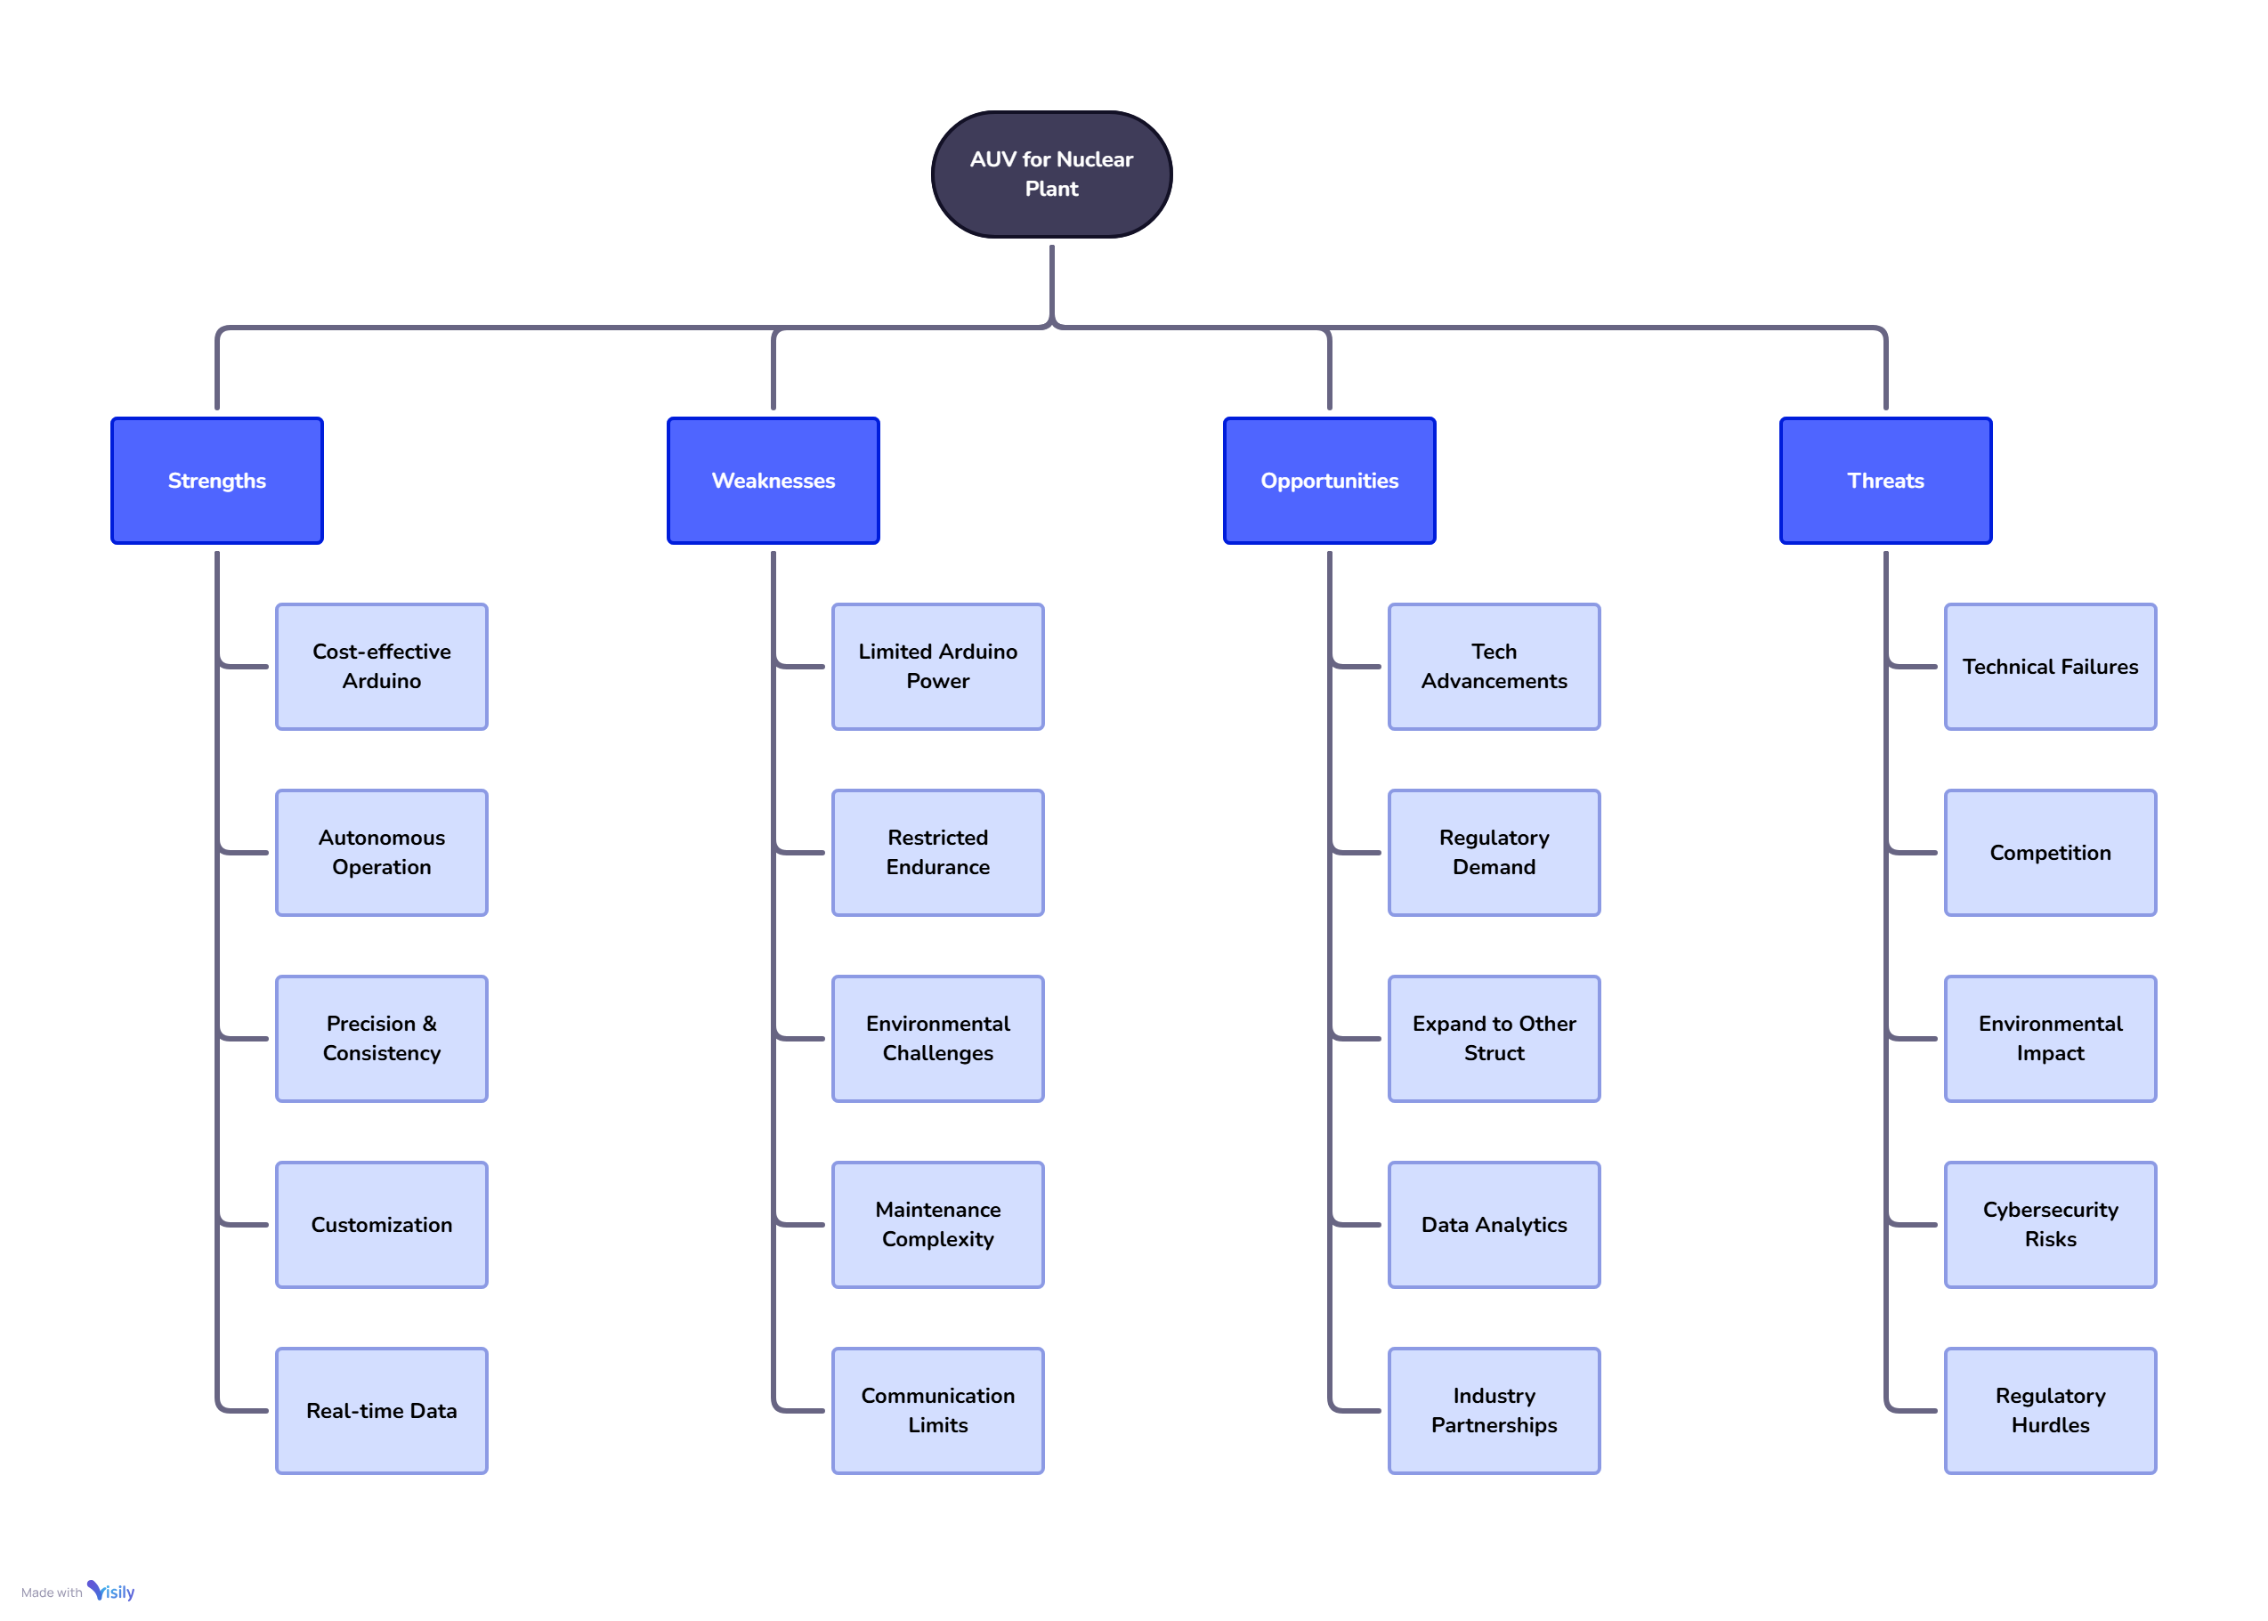
  - Project Plan - GANTT Chart

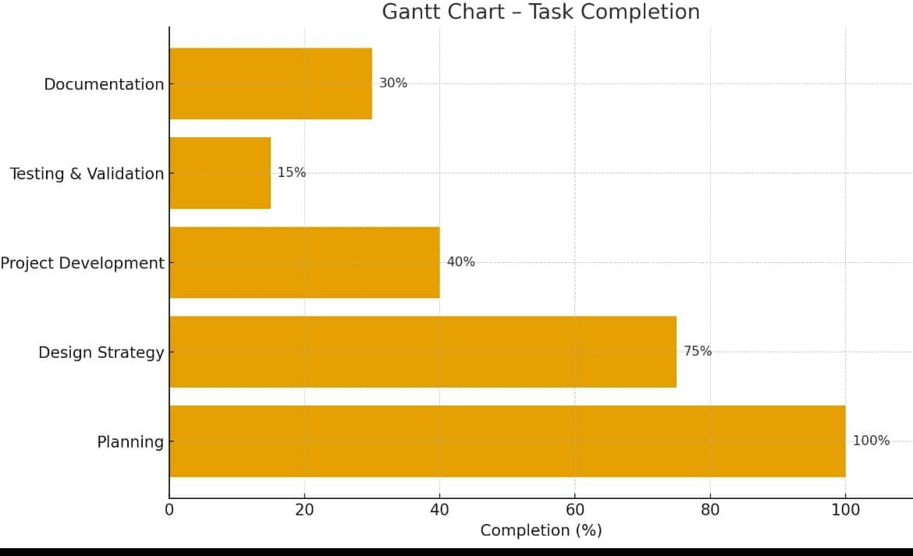

  - Problem statement:
Autonomous underwater vehicle for sea water intake
tunnel inspection and cleaning for nuclear plant
Chapter 4 : Methodology

  - Description of the approach

The methodology to build an Autonomous Underwater Vehicle (AUV) for seawater intake tunnel inspection and cleaning in a nuclear plant involves a systematic, multi-phase approach starting with requirement analysis and site assessment to define tunnel geometry, water conditions, safety, and regulatory constraints. The next step is conceptual design, where the AUV’s structure, propulsion, power system, sensors (cameras, sonar, DVL, IMU), and cleaning tools (brushes, water jets, suction units) are selected to ensure efficient operation in confined, low-visibility environments. This is followed by detailed design and prototyping, including CAD modeling, control system development, and sensor integration. The integrated prototype is then tested in controlled water tanks and mock tunnels to validate navigation accuracy, inspection imaging, and cleaning efficiency while ensuring fail-safe operation and decontamination compliance. Finally, field trials are conducted in actual plant conditions to fine-tune autonomy, communication, and reliability before full deployment for periodic inspection and cleaning of seawater intake tunnels.

  - Tools and techniques utilized

To implement and test the system, the following tools and techniques were used:

1.CAD and simulation software (like SolidWorks, ANSYS, or MATLAB Simulink) for mechanical design, hydrodynamic modeling, and structural analysis;
2.Pressure-resistant hull fabrication tools for assembling corrosion-resistant enclosures using materials such as stainless steel or titanium;
3.Embedded control systems and microcontrollers/ROS-based platforms for real-time navigation, autonomy, and data processing;
4.Sensor integration techniques combining sonar, cameras, IMU, and DVL for precise localization and mapping in turbid, GPS-denied environments;
5.SLAM (Simultaneous Localization and Mapping) and image-processing algorithms for tunnel mapping and defect detection;
6.Cleaning tool systems such as rotary brushes, controlled-pressure water jets, and suction mechanisms designed for biofouling removal without surface damage;
7.Testing and calibration setups like water-tank mock tunnels for validating propulsion, buoyancy, and inspection performance; and
8.Data acquisition and analysis tools for logging inspection data, monitoring AUV health, and generating maintenance reports compliant with nuclear-safety standards.

  - Design considerations

During the design of the adaptive modulation scheme, the following considerations were taken into account:
1.Structural and Material Selection: The AUV must be compact, pressure-resistant, and made from corrosion-resistant, non-contaminating materials such as stainless steel or titanium to withstand seawater and allow easy decontamination in a nuclear environment.

2.Navigation and Control System: The AUV should include reliable sensors like DVL, IMU, sonar, and cameras for precise localization and autonomous navigation in GPS-denied, low-visibility tunnels with stable control and obstacle avoidance.

3.Power and Propulsion Design: Efficient thrusters and hydrodynamic design are essential to ensure smooth movement, low power consumption, and sufficient endurance for long tunnel inspections while maintaining maneuverability in confined spaces.

4. Inspection and Cleaning Mechanisms: The AUV must integrate modular tools such
as cameras, ultrasonic sensors, brushes, and controlled water jets to perform detailed
inspection and cleaning without damaging tunnel walls or coatings.

5. Safety and Fail-Safe Mechanisms: The system should include emergency recovery, communication redundancy, buoyancy control, and radiation-safe components to ensure safe operation and easy retrieval in case of malfunction within the nuclear plant environment.

Chapter 5 : Implementation

  - Description of how the project was executed

- Built and tested prototype AUVs in laboratory pools.
- Integrated advanced navigation and cleaning mechanisms.
- Conducted phased deployment in inactive and then active tunnels.
- Fine-tuned operation through multiple test cycles and feedback

  - Challenges faced and solutions implemented

- Communication issues in confined, high-metal environments—solved with relay robots and optical comms.​
- Sensor fouling and energy constraints—addressed via regular cleaning cycles and optimized energy usage.​
- Obstacle avoidance and data transmission reliability—improved with advanced sensors and software algorithm

Chapter 6: Results

  - Outcomes-
DEPTH CONTROLLER:

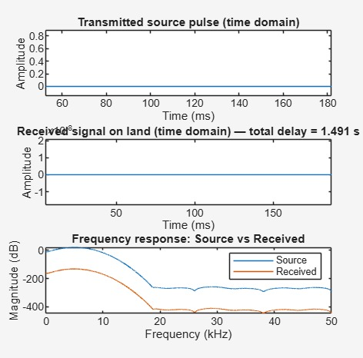

land to sea communication:

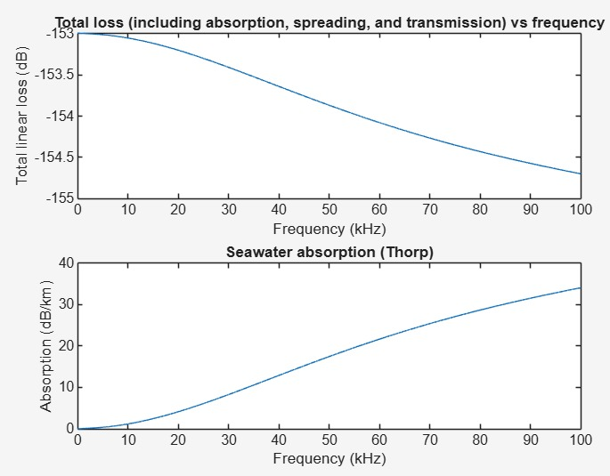

Underwater acoustic propagation:

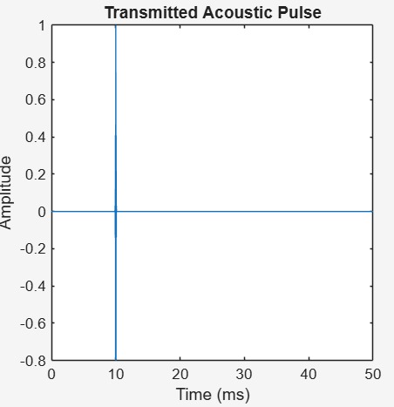

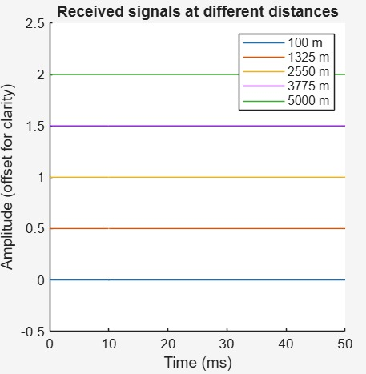

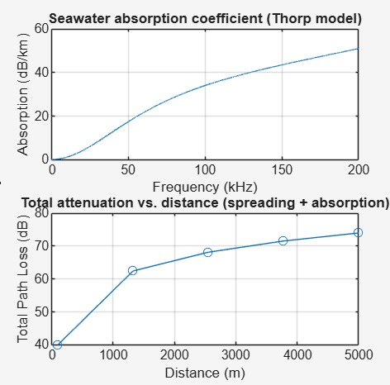

DEPTH ESTIMATION SOALR:
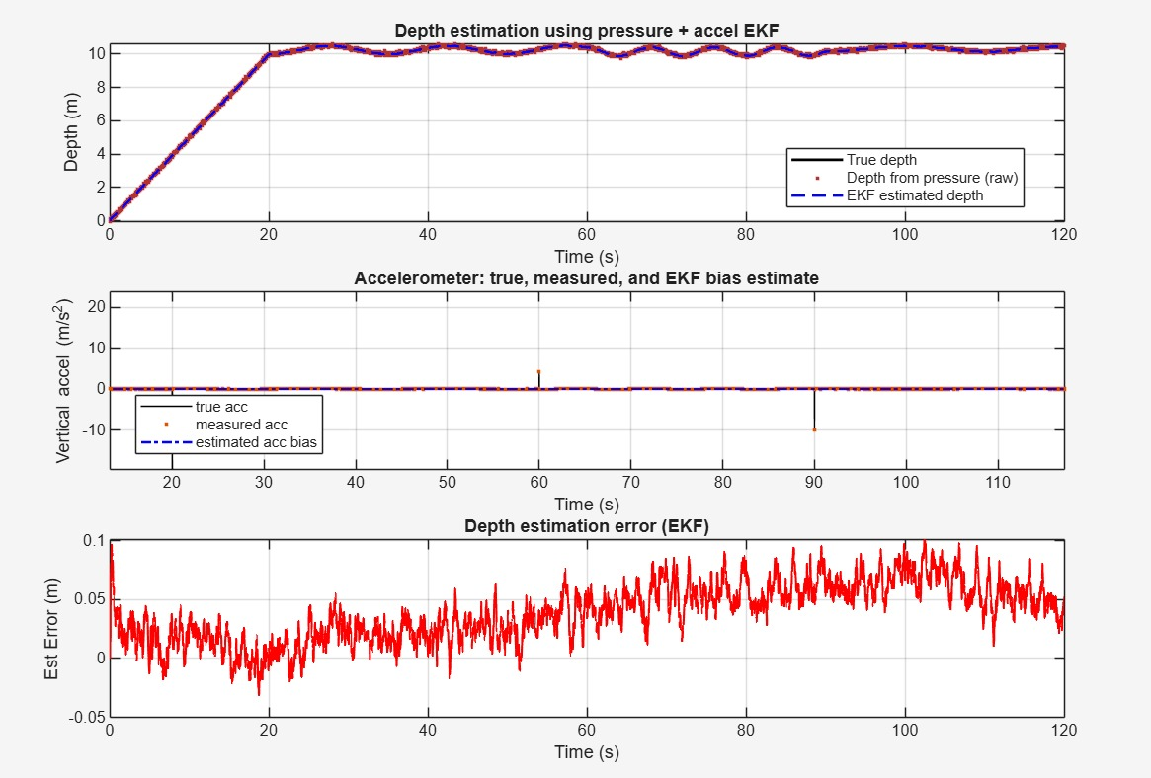

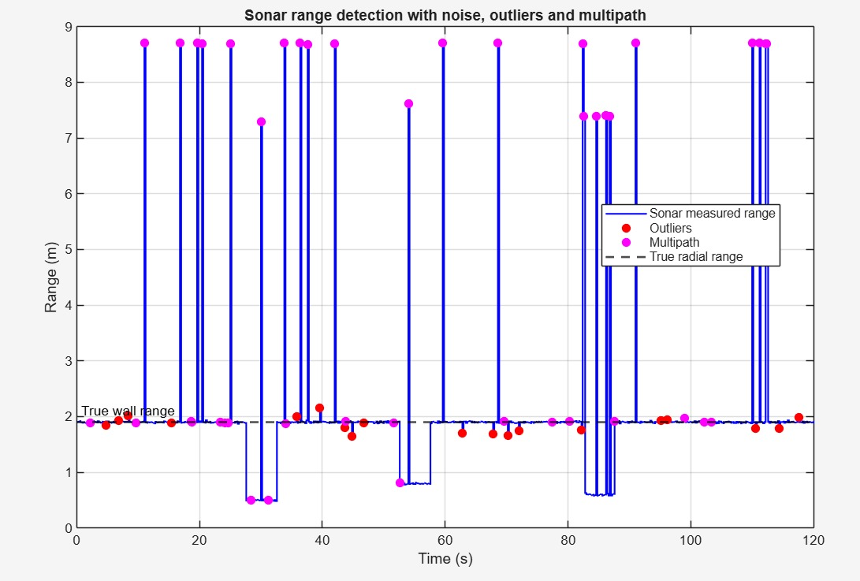

  - Interpretation of results:-

*DEPTH CONTROLLER-

- The transmitted source pulse is initially strong, but as it travels underwater, the received signal on land arrives after a significant delay and with much weaker amplitude.

- The frequency response plot reveals major attenuation at higher frequencies, indicating underwater environments tend to absorb and weaken high-frequency signals much more than low-frequency ones.

- Overall, signals for depth control experience time delays and frequency-dependent loss, which must be addressed in the controller's design to ensure effective underwater vehicle performance

*LAND TO SEA COMMUNICATION-

- The Problem is Absorption:- This shows the use a higher frequency (a higher-pitched sound, measured in kHz), the seawater absorbs much more energy from the signal. This absorption starts small but increases sharply, reaching over 30 dB/km at 100 kHz.

. High Frequencies Fail:- Because high-frequency signals are absorbed so quickly by the water, the total signal loss (top graph) increases as the frequency goes up.

* Underwater acoustic propagation:-

  - Absorption (The Distance Problem)-
Sound gets weaker as it travels through water because the water absorbs its energy. High-pitch (high-frequency) sounds get absorbed very quickly and can’t go far. Low-pitch (low-frequency) sounds travel much farther, which is why they’re used for long-distance underwater communication.

2. Total Signal Loss (The Fading Problem)-
As sound moves through water, it not only gets absorbed but also spreads out in all directions, weakening it even more. This means the farther the sound travels, the weaker it becomes. After about 5 km, most signals lose almost all their strength.

3. Measurement Challenges (The Accuracy Problem)-
Underwater sonar readings are often noisy and unreliable. Some signals bounce off surfaces like the sea floor or the water surface before reaching the receiver — this “multipath” effect causes errors because the sound takes longer to return, leading the system to think the object is farther away than it really is.

* DEPTH ESTIMATION SOALR:

- Underwater vehicles need to know their depth very accurately, but each sensor alone can make mistakes.

- The two main sensors used are:
  - A pressure sensor, which is usually noisy (the readings jump around).

- By using EKF, both sensors’ data are combined smartly:
  - The EKF smooths out the noisy pressure data using the accelerometer readings.
  - The EKF also learns and corrects for the small error in the accelerometer.

- The final result is a depth estimate that matches the true depth closely, with very little error—within ±10 cm—which is very precise for underwater work.

  - Comparison with existing technologies:

- Many current systems focus on visual inspection only, while the developed AUV integrates autonomous navigation, inspection sensors, and cleaning tools to perform both inspection and maintenance without human risk, representing a significant improvement.

- Literature reveals increasing use of autonomous systems in nuclear environments to reduce radiation exposure, improve efficiency, and perform tasks like visual inspection, structural assessment, and even localized cleaning or repair, which aligns with the AUV’s multifunctional design.

- The developed AUV uses advanced sensor fusion (like Extended Kalman Filters) for precise navigation and depth control, which offers enhanced accuracy and reliability compared to older methods that used single sensors or manual control.

- Energy systems in cutting-edge AUV research are exploring high-density and long-endurance options (like aluminum-water reactions), enabling longer missions without recharge, which complements mission demands in nuclear plant environments.

- Overall, compared to existing technologies, the developed AUV offers improved autonomy, safety, precision, and multifunctional capability that aligns well with ongoing advances in underwater robotics for nuclear plant maintenance and inspection.​

Chapter 7: Conclusion

Here write Suggestions for further research or development and Potential improvements or extensions

- AUVs reduce risk by avoiding human divers and improve inspection accuracy and cleaning efficiency compared to older manual or tethered methods.

- Future research should focus on making AUVs smarter, enabling them to make decisions on where to inspect and clean without human input.

- Improving sensors and navigation will help AUVs better handle complex tunnel environments and provide more detailed inspections.

- Adding multifunctional tools like robotic arms for minor repairs and more effective cleaning devices will expand their usefulness.

- Enhancing battery life and energy efficiency will allow longer missions, reducing downtime.

- Making AUVs smaller and more maneuverable will help them operate in tight spaces in intake tunnels.

- Integrating reliable communication and fail-safe systems ensures safe retrieval and continuous operation.

- These advancements will lead to safer, more cost-effective, and thorough maintenance of critical nuclear plant underwater infrastructure

Chapter 8 : Future Work-

Here write Suggestions for further research or development Potential improvements or extensions

- Future research can focus on making these underwater robots smarter by giving them AI to better analyze inspection data and decide where cleaning or repairs are needed without human help.

- Improving underwater communication systems will help AUVs stay connected and controlled even in challenging tunnel environments.

- Enhancing battery life and energy management will allow longer missions, reducing downtime for recharging or retrieval.

- Developing modular AUV designs that can add or swap tools like welding arms or advanced cleaning devices will extend their capabilities.

- Smaller, more maneuverable AUVs can better navigate tight spaces inside tunnels.

- Incorporating more reliable autonomous navigation and obstacle avoidance will increase safety and efficiency.

References

1. A Comprehensive Study on Modelling and Control of Autonomous Underwater Vehicle
- Author: Rajini Makam, Pruthviraj Mane, Suresh Sundaram, P.B. Sujit
- Journal: Not specified
- Key Takeaways: This study provides a comprehensive overview of AUV modeling and control strategies, highlighting the importance of accurate hydrodynamic modeling and robust control systems for AUVs operating in challenging underwater environments.

2. A review on the hydrodynamic characteristics of autonomous underwater vehicles
- Author: Jyoti Prakash Panda, Arindam Mitra, Hari V Warrior
- Journal: Journal of Ocean Engineering
- Key Takeaways: This review paper discusses various experimental and numerical methods for analyzing hydrodynamic characteristics of AUVs, emphasizing the importance of understanding these characteristics for better design, control, and navigation.

3. Autonomous Underwater Vehicles and Field of View in Underwater Operations
- Author: Isaac Segovia Ramírez, Pedro José Bernalte Sánchez, Mayorkinos Papaelias, Fausto Pedro García Márquez
- Journal: Journal of Marine Science and Engineering
- Key Takeaways: This paper explores the importance of field of view in underwater operations and discusses how AUVs can be used to optimize inspection and monitoring tasks.

4. Autonomous Underwater Vehicles: Identifying Critical Issues and Future Perspectives in Image Acquisition
- Author: Alberto Monterroso Muñoz, Maria-Jose Moron-Fernández, Daniel Cascado-Caballero, Fernando Diaz-del-Rio, Pedro Real
- Journal: Sensors
- Key Takeaways: This study identifies critical issues in AUV image acquisition, including optical issues, underwater image enhancement, and algorithmic processing, and proposes a global underwater workflow for future applications.

5. Advancements in the field of autonomous underwater vehicle
- Author: A. Sahoo, S. K. Dwivedy, P. S. Robi
- Journal: IEEE Journal of Ocean Engineering
- Key Takeaways: This paper reviews recent advancements in AUV technology, including design, control, and navigation systems, highlighting their applications in various fields.

6. On the Study of Autonomous Underwater Vehicles by Computational Fluid Dynamics
- Author: João Victor Nunes de Sousa, Antonio Gilson Barbosa de Lima, Francisco Alves Batista, Edna Cordeiro de Souza, Daniel César de Macedo Cavalcante, Paulo de Morais Pessôa, João Evangelista Franco do Carmo
- Journal: Open Journal of Fluid Dynamics
- Key Takeaways: This study demonstrates the use of computational fluid dynamics (CFD) in analyzing the hydrodynamic performance of AUVs, providing insights into their design and optimization
.


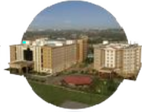
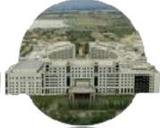
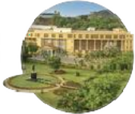
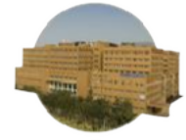
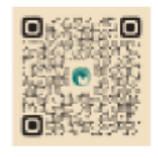

Bengaluru City Office No 5/1, First Floor, Prestige Terraces, Union Street, Infantry Road, Bengaluru - 560003 Karnataka, India

GIMSR
GITAM Medical College Rd, Gandhi Nagar, Rushikonda, Visakhapatnam - 530045 Andhra Pradesh, India

